**Email Integration**

-----------------------

In case, if a job fails, we need to send notification.

For that we need to integrate jenkins to smtp server.

We are now integrating jenkins with gmail smtp server.

Search in google "gmail smtp server"

SMTP server: smtp.gmail.com

Port: 465

Maha1982002@gmail.com

+++++++++++++

Manage Jenkins --- Configure System

Email Notification

SMTP Server - smtp.gmail.com

Click on Advance button (with notepad icon)

USE SMTP Authentication

Username – [maha1982002@gmail.com](mailto:maha1982002@gmail.com) (From address)

Password - password for the above email

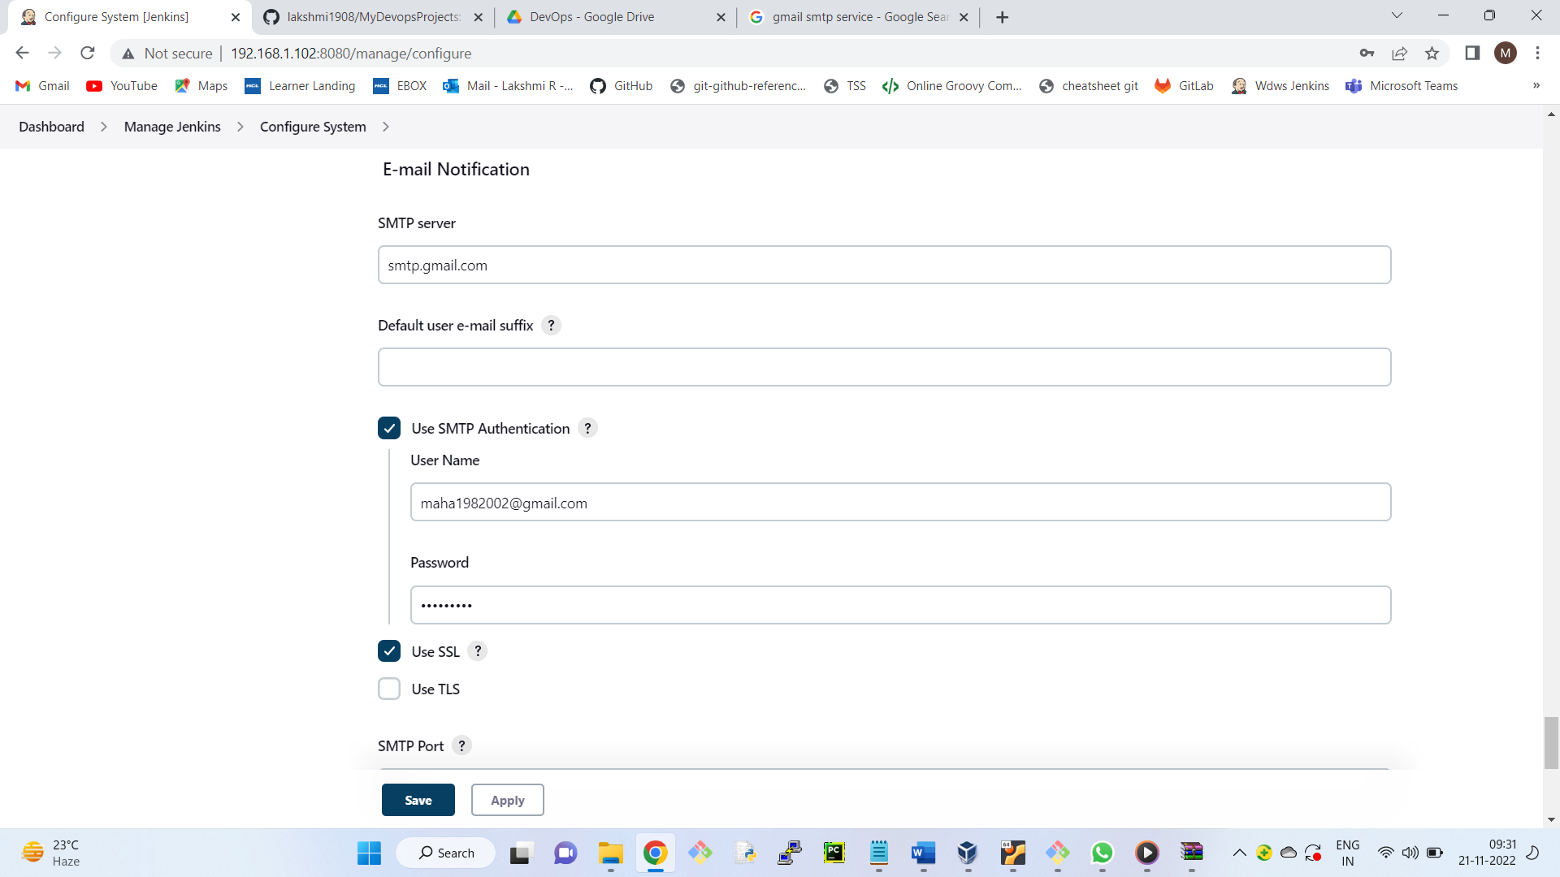

use SSL

SMTP Port - 465

Test Configuration by sending e-mail.

Test email Receipent – [maha1982002@gmail.com](mailto:maha1982002@gmail.com)

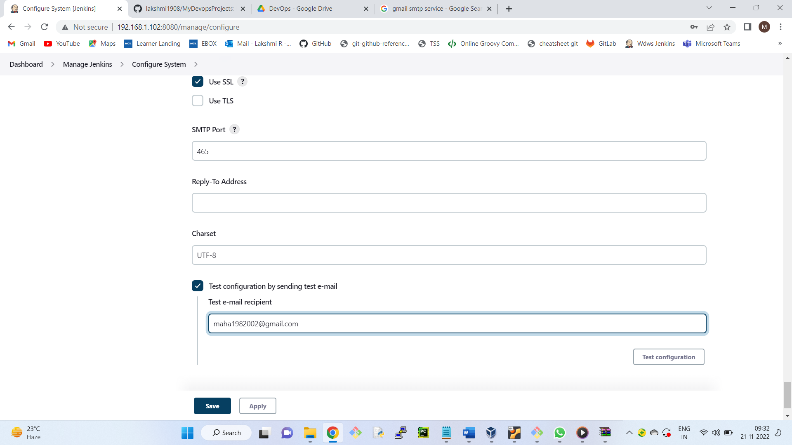

(We should get success message)

-----------------------------

Gmail Settings to get email from jenkins

1) Go to google account -- Less secure app access --- Allow less secure apps: ON

+++++++++++++++++++++++++++++++

It’s time to test

Create a new job in jenkins ---- with a simple echo statement -- Link email in new job --- It will run successfully.

Post Build Actions Tab, we have email notification

Willingly make an error, we get email triggered.

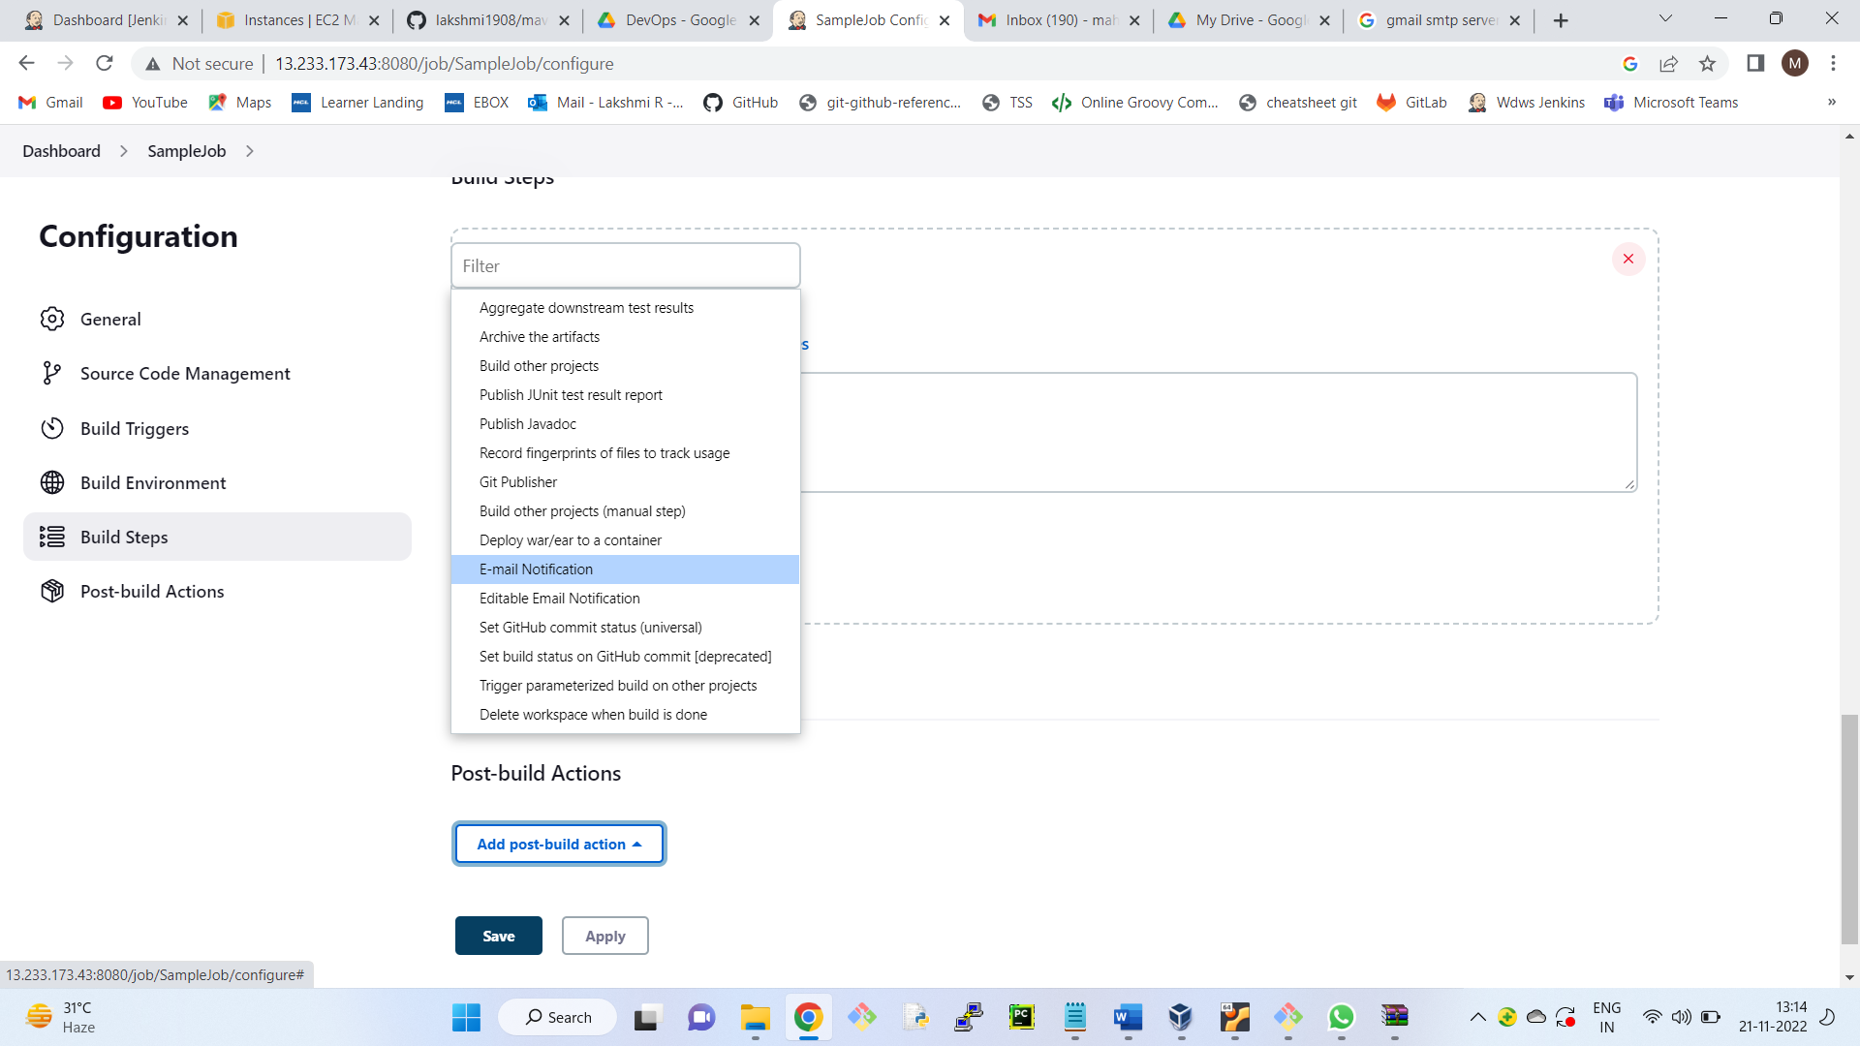

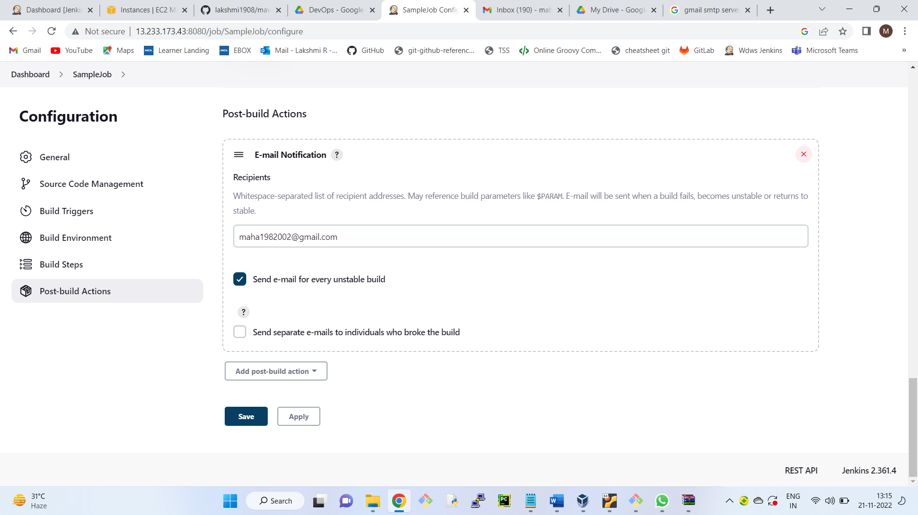

echo " Hello Jenkins" -- Instead of echo

ech " Hello Jenkins"

++++++++++++++++++++++++++++++++++++++++++

Build Periodically

To build the job periodically

We use cron job format

We need to give 5 values 30 21 * * *

“ * ” Refers to all

Min - 0-59

hour - 0-23

day of month - 1-31

month - 1-12

days of week- (0–7) where 0 and 7 are Sunday.

Let’s say you want to run the job every day at 9:30 PM

30 21 * * *

Let’s say you want to run the job every day at 9:30 PM from Mon to Friday

30 21 * * 1-5

To run the job every minute

* * * * *

-----------------

Under source code management tab

Build Triggers --- Build periodically

Schedule -

----------------------------